

**SIR SYED**

**CENTER FOR ADVANCED STUDIES IN ENGINEERING**

**INSTITUTE OF TECHNOLOGY**

**ISLAMABAD**

**COMMUNICATION**

**&**

**PRESENTATION SKILLS**

**ASSIGNMENT: 1**

**Submitted To:**

**MA'AM SANA MOHSIN**

**TEACHER**

**COMMUNICATION & PRESENTATION SKILLS**

**Submitted By:**

**Abdul Malik (BSCYS-019-FA21)**

**Muhammad Panah (BSCYS-017-FA21)**

**Anum Abid (BSEE-013-FA21)**

**Manal Anwar (BSEE-010-FA21)**

**Table of Contents**

**Abstract:** 2

**1. Introduction:** 3

FEATURES: 3

1.1 Background Study: 3

1.2 Problem Statement: 4

1.3 Aims and Objectives: 4

1.4 Justification of Research: 5

1.5 Scope of study: 5

Limitations: 5

1.6 Organization of the Research: 6

**2. Literature Review:** 6

2.1 Historical Background: 6

2.2 Literature Review Matrix: 6

2.3 Block diagram and aids to illustrator existing work: 9

2.4 Summery: 9

**3. Proposed Methodology:** 9

3.1 Introduction: 9

3.2 Proposed Methodology: 10

3.3 Expectations of the Models Used: 10

3.4 Flow Charts: 11

3.5 Data Acquisition: 11

3.6 Summary: 11

**4. Results and Discussions:** 12

4.1 Outputs with Visual: 12

4.2 Graphs: 12

4.3 Histograms: 12

4.4 Simulations: 12

4.5 Tables: 12

**5. Conclusion and Future Work:** 12

5.1 Conclusion: 12

5.1 Future Work: 12

# 

**List Figures:**

Figure 1 11

Figure 2 13

Figure 3 15

Figure 4 15

Figure 5 16

Figure 6 16

Figure 7 16

Figure 8 17

Figure 9 17

Figure 10 18

Figure 11 18

Figure 12 19

Figure 13 19

Figure 14 20

# **Abstract**

The system aims at the maintenance and management of the different libraries that are available in the different parts of the world. It mainly takes care of the library management at the core area of the database. The system provides the information on how many books are present in library, how many have been borrowed and how many books can be bought. The readers can use software and register themselves with the required information that is expected by the system. This system is created using C++. This system is tested many time to assure that it works properly.

The Library Management System is an application for assisting a librarian in managing a book library in a university. The system would provide basic set of features to add/update members, add/update books, and manage check in specifications for the systems based on the client’s statement of need.

Library management system is a typical management Information system its Development include the establishment and maintenance of back-end database and front-end application development aspects. For the former require the establishment of data consistency and integrity of the strong data security and good libraries. As for the latter requires the application fully functional, easy to use and so on.

# 1. [Introduction:](https://itsourcecode.com/free-projects/cplusplus-projects/library-management-system-project-in-c-and-mysql-database/)

The project titled Library Management System is Library Management software for monitoring and controlling the transactions in a library .The project “Library Management System” is developed in C++, which mainly focuses on basic operations in a library like adding new books, and updating new information, searching books and members and return books.

This project of “LIBRARY MANAGEMENT” of gives us the complete information about the library. We can enter the record of new books and retrieve the details of books available in the library. We can issue the books to the students and maintain their records and can also check how many books are issued and stock available in the library. In this project we can maintain the late fine of students who returns the issued books after the due date.

The library management system as the name implies is a piece of software that manages all of the library’s data instead of writing data in notebooks, it makes librarian work easier. Librarians keep track of book data in notebooks along with names of students who borrowed the book.

As a result, keeping track of every book was extremely tough. If the librarian wants to look for a specific book, that track takes a long time. so programming languages were created to make work easier, and C++ is one among them.

### **[FEATURES](https://www.academia.edu/52082166/Service_model_for_libraries_in_an_agricultural_environment_with_specific_reference_to_the_library_of_the_ARC_Small_Grain_Institute):**

* Librarian will have his/her own logins, with the librarians password safeguard.
* The librarians can update, add, delete and create books in this project, as well as assign them to pupils.
* Students also get the books of all the books that are available in the library database.
* The librarians have complete control over adding books, assuming books and modifying books.
* To keep the data of books in a project, the project employs file handling.
* The project's major characteristics include reissuing and returning books.
* The student can also check to see if the book has previously been borrowed by another student.

## **1.1** [**Background Study**](https://www.paldesk.com/why-is-technology-important-for-productivity/)**:**

Nowadays, in a highly technological society, human productivity is made more efficient through the development of electronic gadgets. Technologies are important and helpful in everyone’s life. A library is a place in which literary and artistic material such as books, periodicals, newspapers, pamphlets, prints, records, and tapes, are kept for reading or for reference

library is a collection of such materials, especially. A library management system is made to have fast process transaction for searching book titles, borrowing books, returning books, computing penalties and generating an accurate report. Library is a place in which we get information in any format and from many sources. This involves the utilization for processing, accessing and retrieving the information that can effectively support the process of student’s learning and decision-making.

## **1.2** [**Problem Statement**](https://www.academia.edu/25553795/Library_Management_system_Problem_and_its_Background_Problem_and_its_Background)**:**

Students often find problems because books are limited and only few students can have the books. Students need to fall in line and then ask for the related title of the books. Through this, some students are not able to follow their lessons.  
The answer for this problem is the enhancement of technology by developing the Library Management System. The efficiency of a library lies on how books are arranged and how easily one can get the books of their choice. They can easily control all the students borrowing and returning the books.

The efficiency of a library lies on how the books and other materials are arranged and how easily one can get the books of their choice. Generally, what we see nowadays is the manual library management system whose process of operation is very much hectic.

What we are doing is that we are proposing a computerized library management system, which provide better and efficient service to the library members. This software is meant to transform the hectic manual system to a more efficient computerize system

## **1.3 Aims and Objectives:**

**We have following Aims and Objectives:**

* To design, develop, and implement a library system that will speed up library transactions processes.
* To design and develop a less time consumed in browsing the availability of the books.
* To design and develop a computerized based system for faster and easier reports.

## **[1.4 Justification of Research:](https://www.ashishvegan.com/techvegan/libray-management-system-free-source-code-download.php)**

Library Management system helps in maintaining data of books issued to learners and books available in the library. This helps librarians spot any particular book at any given time in the library. The library management systems can be easily customized as per individuals’ requirements. Its an easy-to-use interface and immediate reporting make things easier for the school library staff and It is also convenient for students of K12 and higher education. Unlike higher education schools needs more caution and highly smart software to manage the library as school’s students are not that careful with the books.

## **1.5 Scope of study:**

**File maintenance**

The system will let the user add, edit and delete the following:

* Books
* Student
* Category
* Transactions
* Borrowing: In borrowing transaction, the information of a book will be automatically displayed by the system and shows if the particular book is available or not.
* Returning: In returning transaction, penalty will be automatically computed for the overdue and lost books.

**Reports**

The generation of reports will be generated daily, monthly, and annually by the librarian. The reports include the following:

* List of books
* List of books added
* List of books deleted
* List of added books edited

### **Limitations:**

The proposed system will not cover online reservation the proponents intend to develop will not handle online reservation of books because the system is not a web-based

## **[1.6 Organization of the Research:](https://www.academia.edu/5754413/STUDENT_INFORMATION_MANAGEMENT_SYSTEM)**

The study gave birth to a new system designed to bring efficiency in the library system operations. It will eliminate some of the problems associated with the old (manual) system of library management, which include cost of equipment and staff maintenance and also allow institutions to manage the affairs of libraries easily.

# 2. Literature Review:

## **[2.1 Historical Background:](https://www.modishproject.com/design-and-implementation-of-school-library-information-system/)**

A library can be defined as a room or building where books are kept and referenced. It is an area of multifarious activity on book management. A library as a repository of knowledge, houses collections of books, both reference and general, technical reports, periodicals, journals, conference proceedings and the likes.

Libraries originated with writing about 6000 years ago and that was when writing was being done using materials like bones, clay, wax, papyrus, metals, silk, leather, parchment, paper, and other available materials. Later, these materials were assembled together to form libraries. Among the earliest libraries were ANCIENT LIBRARIES OF CLAY, which emerged in Iraq and other Mesopotamian region like Syria and Turkey. In these libraries, records were kept on clay tablets. Within that period were also ANCIENT LIBRARIES OF ANIMAL SKIN.

The history of library development in Nigeria is of recent vintage. In fact, the earliest library in Nigeria was Tom Jones Library, which was established in 1910. That was the first public subscription library in Nigeria. The beginning of academic library was marked in Nigeria with the founding of Yaba Higher College in 1948. Later on the British council took over the library sense with the foundation of the first municipal council library in Lagos, and established British council libraries in various parts of the country.

Unfortunately, these became a great loss of library stock after the Nigerian Civil War, and the federal government then took it as part of its rehabilitation effort in promulgating the National Library’s decree of 1970, which provided for the branches to be set up in every state of the federation. the National Library has succeeded in stock over 75000 volumes, 2000 period leads, 150 Newspapers and became a depository for the United Nations Organization (UNO) and its agencies. Literature review matrix is shown in below table

|  |  |  |  |
| --- | --- | --- | --- |
| Limitations | Strength | Title | Author |
| NOT FOUND | To find out the hidden valueable information or some associations rules of a large amount of information in current library books management system | University Library Management Based on Improved Collaborative Filtering Association Rules Algorithm | Yangdi Lia, 2018 |
| The resulting model has potential applications such as in the structuring analysis of academic library performance, mapping future directions of development and for exploring variations across the sector and internationally. | conceptualise the issues of alignment for changing academic libraries by using and extending McKinsey’s 7S model. | 7S model to understand strategic alignment in academic libraries | McKinsey, 2018 |
| The paper provides a helpful inspiration for Big Data mining and software development, which will improve their efficiency and insight on users’ behavior and psychology. | The paper proposes a framework to help users understand others’ behavior, which will aid them better take part in group and community with more contribution and delightedness. | Library personalized recommendation service method based on improved association rules | [Kaigang Yi](https://www.emerald.com/insight/search?q=Kaigang%20Yi), 2017 |
| The scope of study describing the status of library marketing research is limited to the period 2006–2017. The results of the study should interest researchers in finding solutions to formulating future library strategies and programs for achieving sustainable growth in this area of study. | The present study in library marketing research should be of interest to researchers in evolving, and formulating theories/best practices/and policies/programs for outreach to current and potential users for promoting library products and services. | Global library marketing research | [Dinesh K. Gupta,](https://www.emerald.com/insight/search?q=Dinesh%20K.%20Gupta) [B.M. Gupta,](https://www.emerald.com/insight/search?q=B.M.%20Gupta) [Ritu Gupta](https://www.emerald.com/insight/search?q=Ritu%20Gupta), 2016-2017 |
| The research focuses only on software packages which are available in Delhi. | No comprehensive survey has been carried out regarding the web interface for Library Management Software Systems in India. | Comparative features of integrated library management software systems available in Delhi | [Namrata Rai,](https://www.emerald.com/insight/search?q=Namrata%20Rai) [Shailendra Kumar](https://www.emerald.com/insight/search?q=Shailendra%20Kumar), 2011 |
| NOT FOUND | The task of evaluating integrated library systems is necessary to choose the most appropriate library management system that will answer the needs of the library in automating its operations | Integrated Library Management Systems (ILMS) - Open Source and Commercial Software | Thuraiyappah Pratheepan, 2016 |
| The major obstacle to library automation in Nigeria has been poor funding. This paper is an eye opener. | Library automation will address the problem of manual processing of materials. It will further mean less drudgery. | Library automation with Koha | [R.A. Egunjobi,](https://www.emerald.com/insight/search?q=R.A.%20Egunjobi) [R.A. Awoyemi](https://www.emerald.com/insight/search?q=R.A.%20Awoyemi), 2012 |
| Circulation is an area where there needs no professional talent but if it is highly labor-intensive and time consuming. Circulation counter transactions are not evenly distributed throughout the working day. | Information processing is done much faster which ensures better work flow through the library. Operating costs can be reduced. | Impact of Library Automation in the Development Era | Shabana Tabusum, 2013 |
| In spite of the efforts by the Kenneth Dike library system in the past ten years to establish itself in the forefront of library automation in Nigeria and keep abreast of developments in the application of ICT to library services and operations. | Project planning and control determines to a very large extent the success of any project. Automation however, is a project that requires careful planning close monitoring of progress, failures.; an~ new challenges | Library Automation In Nigeria The Kenneth Dike Library Experience | Fataki, Olayinka C. , 2017 |
| This article is based on a case study of library automation at the University of Botswana. The results may not therefore be widely replicated. Besides, the article did not delve deep into technology acceptance and diffusion of innovation issues that could illuminate further the case study. | This article is based on practical experiences of library automation at the University of Botswana and its impact on services, and human and physical resources. Previous studies on this subject at the university only covered migration from one system to another and the technical perspectives of the process of library automation. This study is broad in scope covering both technical and managerial processes of managing change in the context of library automation at the University of Botswana. | Library automation in sub Saharan Africa: case study of the University of Botswana | [Stephen Mudogo Mutula](https://www.emerald.com/insight/search?q=Stephen%20Mudogo%20Mutula), 2012 |

## **2.3 Block diagram and aids to illustrator existing work:**

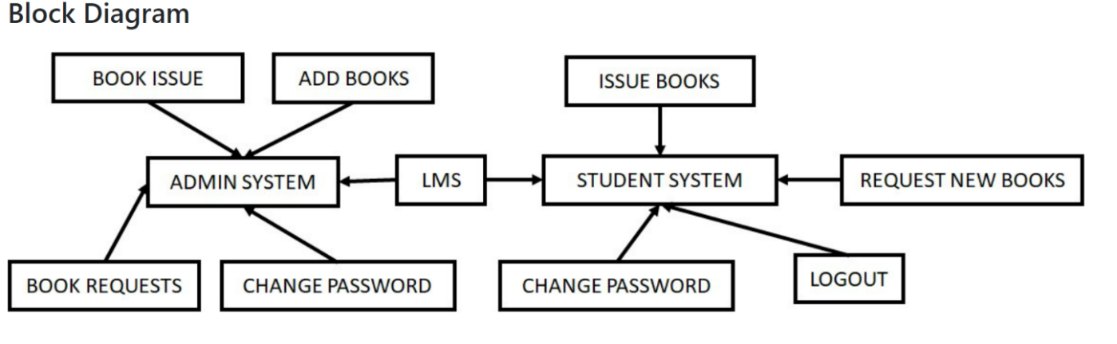

Figure 1

## **2.4 Summery:**

A library management system is software that is designed to manage all the functions of a library. It helps librarian to maintain the database of new books and the books that are borrowed by members along with their due dates. This system completely automates all your library's activities. A library management system is used to maintain library records. It tracks the records of the number of books in the library, how many books are issued, or how many books have been returned or renewed or late fine charges, etc.

You can find books in an instant, issue/reissue books quickly, and manage all the data efficiently and orderly using this system. The purpose of a library management system is to provide instant and accurate data regarding any type of book, thereby saving a lot of time and effort.

# 3. Proposed Methodology:

## **3.1 Introduction:**

Information technology has revolutionized the life of human beings and has made lives easier by the various kinds of applications.in the light of rapid changes with the use of information technology, there are many tools, technologies and systems that has been produced and invented. The main objective of this project is to develop the library management system in order to automate the library tasks and makes the library management more efficient and easy to handle. Library is place where all kind of books are available at hard copy or digital format.so the goal of this project is to developed and implement management system, electronic libraries that will enable easy and effective management of library services, and easy literature search and expend the access reading materials by enabling users and access to access e-books from anywhere within the university.in our existing systems, all the transactions of books are done manually, so taking more time for the transaction like borrowing a book or returning a book and also for searching of the members and books. Library management system is a web application design and developed to help users maintain and organized library.so it possible to generate reports and hard copy.

## **3.2 Proposed Methodology:**

The project library management system is targeted towards the management of a modern library. Proper management of books are possible through an easy to interface for the library staff. The proposed library management system in this proposal will be computerized management system developed to maintain all the daily work of library. Throughout the project the overall focus has been presenting the information and comments in an easy and intelligible manner. The project is targeted to be useful for both library staff and also the borrowers, so we used C++ programming to minimize errors in the system.

**Main modules:**

**Membership management**: to manage the users of library system, their categories, restrictions etc.

**Book management**: to manage the books in the issue and also the reference sections, their classification, department wise distribution, single title calculations etc.

**Serial management**: to manage the periodicals.

**Digital content management**: serial disks and e books are available in the library.

**Reporting:** several reports in different formats will be prepared and submitted to the respective authorities. Every user would be able to find out their historical point of view.

The library management system needs to be computerized to reduce human errors and to increase the efficiency. The proposed library management system in this proposal will be computerized management system developed to maintain all the daily work of library.

## **3.3 Expectations of the Models Used:**

This progam will be able to do folowing tasks

* Add Book.
* Modify Book.
* Delete Book.
* Search Book.
* Issue Book.
* Return Book.

## **3.4 Flow Chart:**

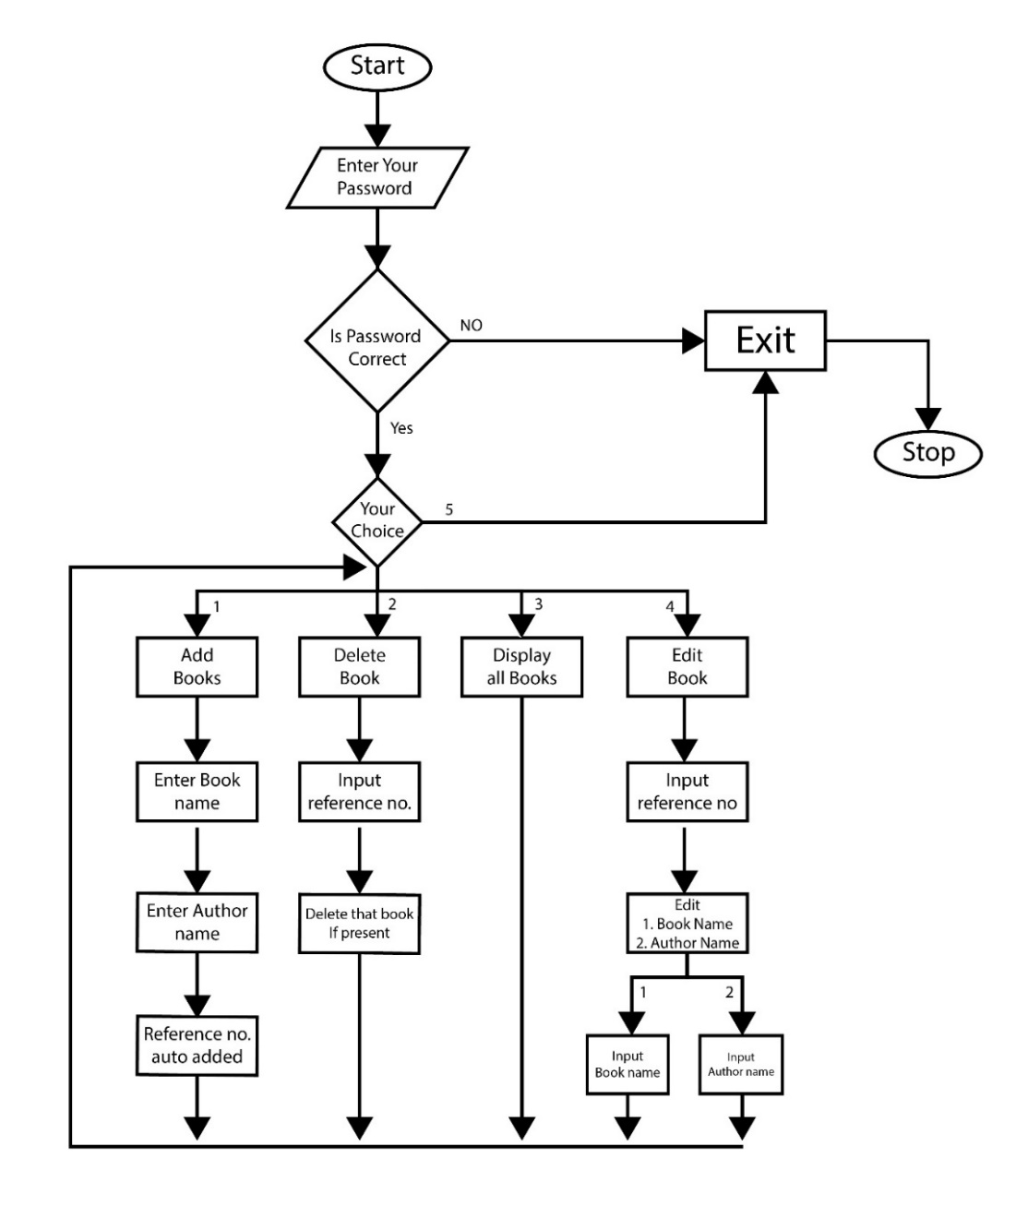

Figure 2

## **3.5 Data Acquisition:**

This library can acquire data for multiple data rates. Mostly this library is not tied to data rate but you can change the parameters for handling the data at your desire rate. This library provides data to the user immediately whatever present in the queue if no data is available it will return Null.  Data is hand-off to the user as soon as the call for data arrives, if data is not available during the call it will return Null.

This library also supports the data saving feature simultaneously to acquisition. As soon as the data arrived it stores the data to a specified location on the hard disk. One can control this behavior of the library by specifying the related parameters.

## **3.6 Summary:**

A library management system is an information system, whether it is computerized or not, is a system that represents objects in a physical system, for example, information resources in a library collection. The catalog discussed in the last chapter represents the actual information resources of a library, whether that representation consists of marks on a card, marks on a microfiche sheet or data stored in a computer.

 A system is something formed of parts, each of which interacts with the other parts to achieve some common purpose. In the case of a library management system, the parts work together to support the management of library information resources, their acquisition, representation and circulation. Each of these parts constitutes a subsystem which in turn comprises a set of interconnected parts. In other words, each of these subsystems can be broken down into yet smaller subsystems. The main objective of this project is to develop the library management system in order to automate the library tasks and makes the library management more efficient and easy to handle. . A library management system is used to maintain library records. It tracks the records of the number of books in the library, how many books are issued, or how many books have been returned or renewed or late fine charges, etc.

# 

# 4. Results and Discussions:

## **4.1 Outputs with Visual:**

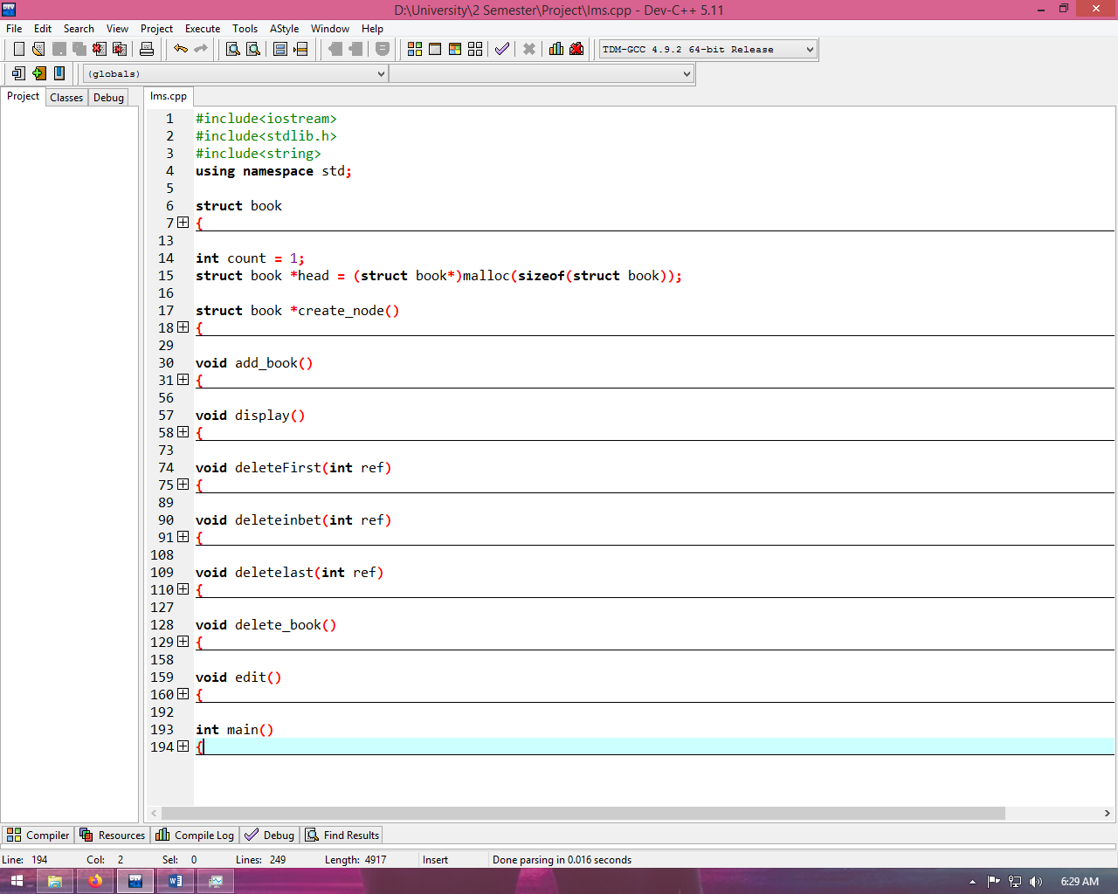

Figure 3

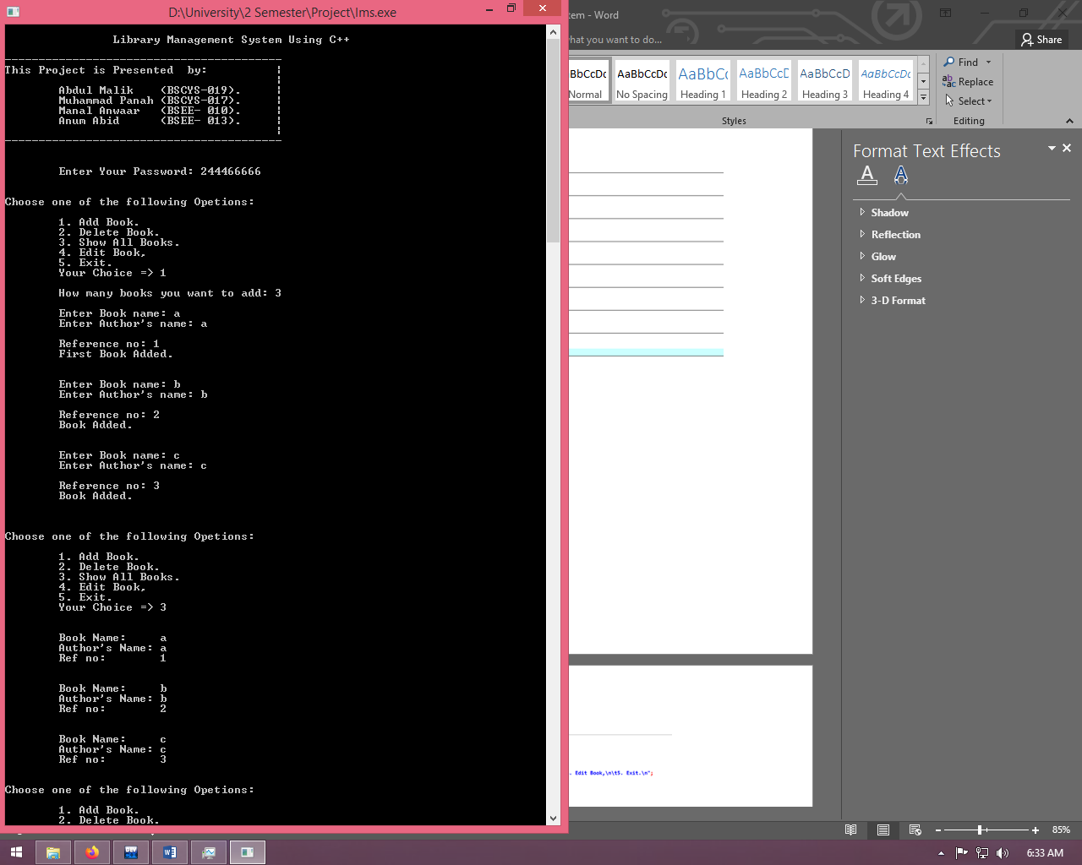

Figure 4

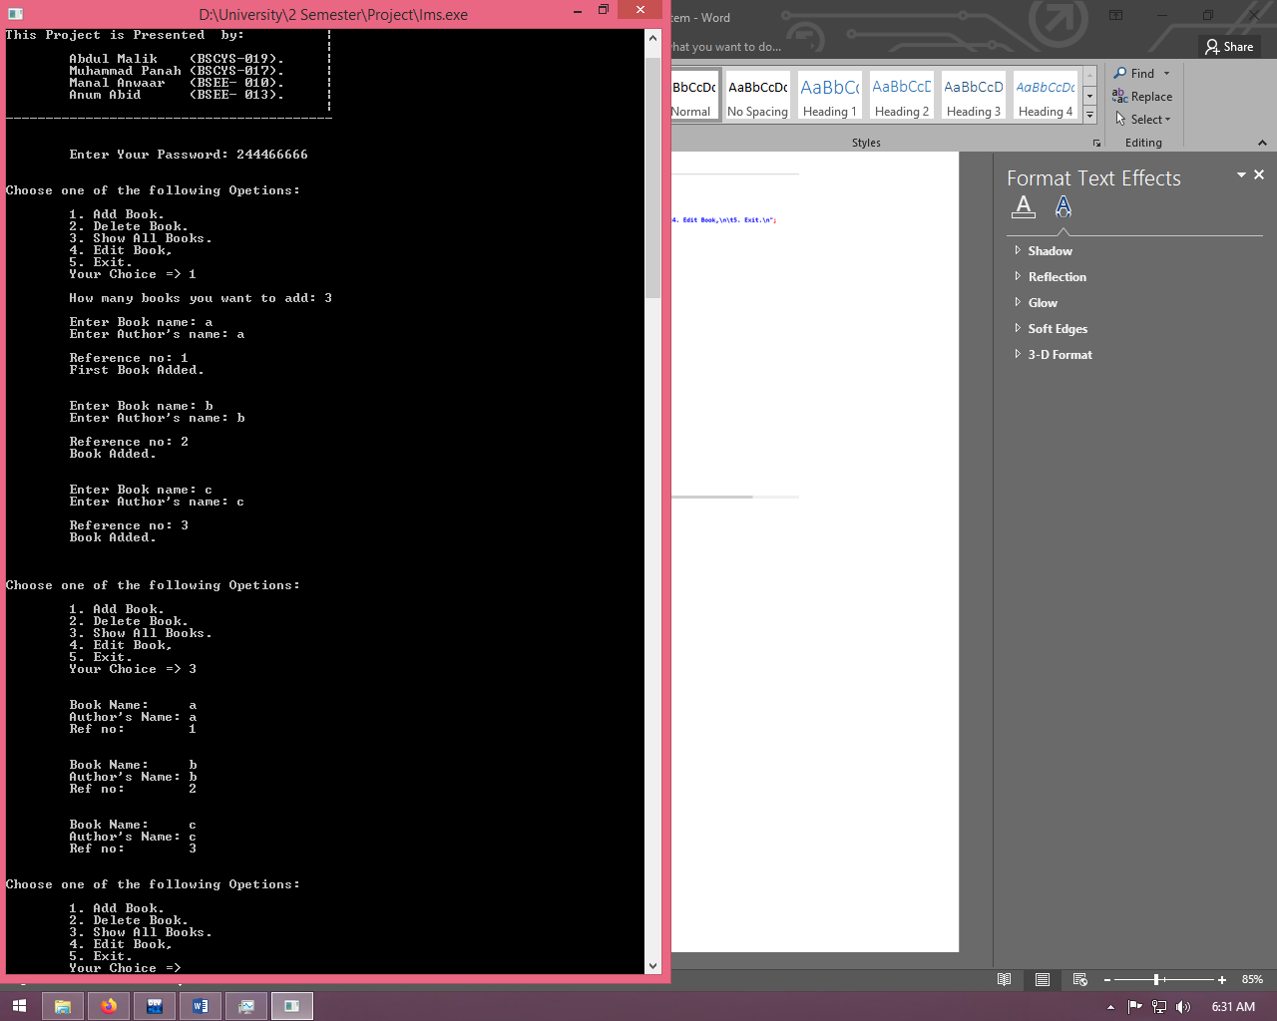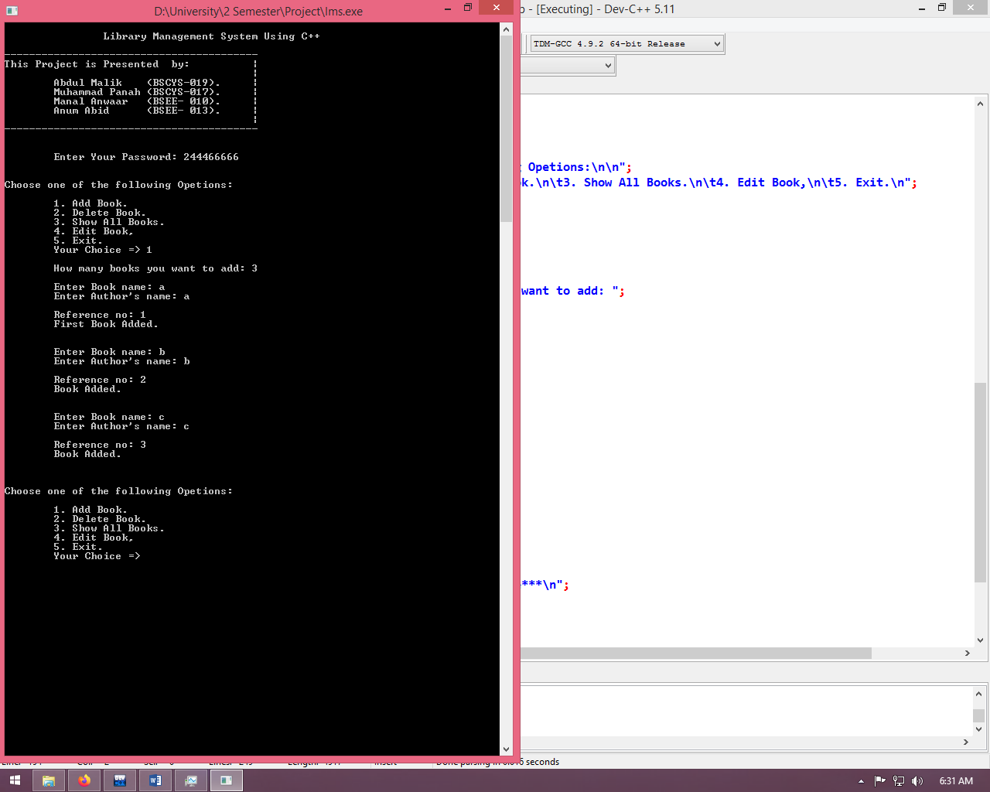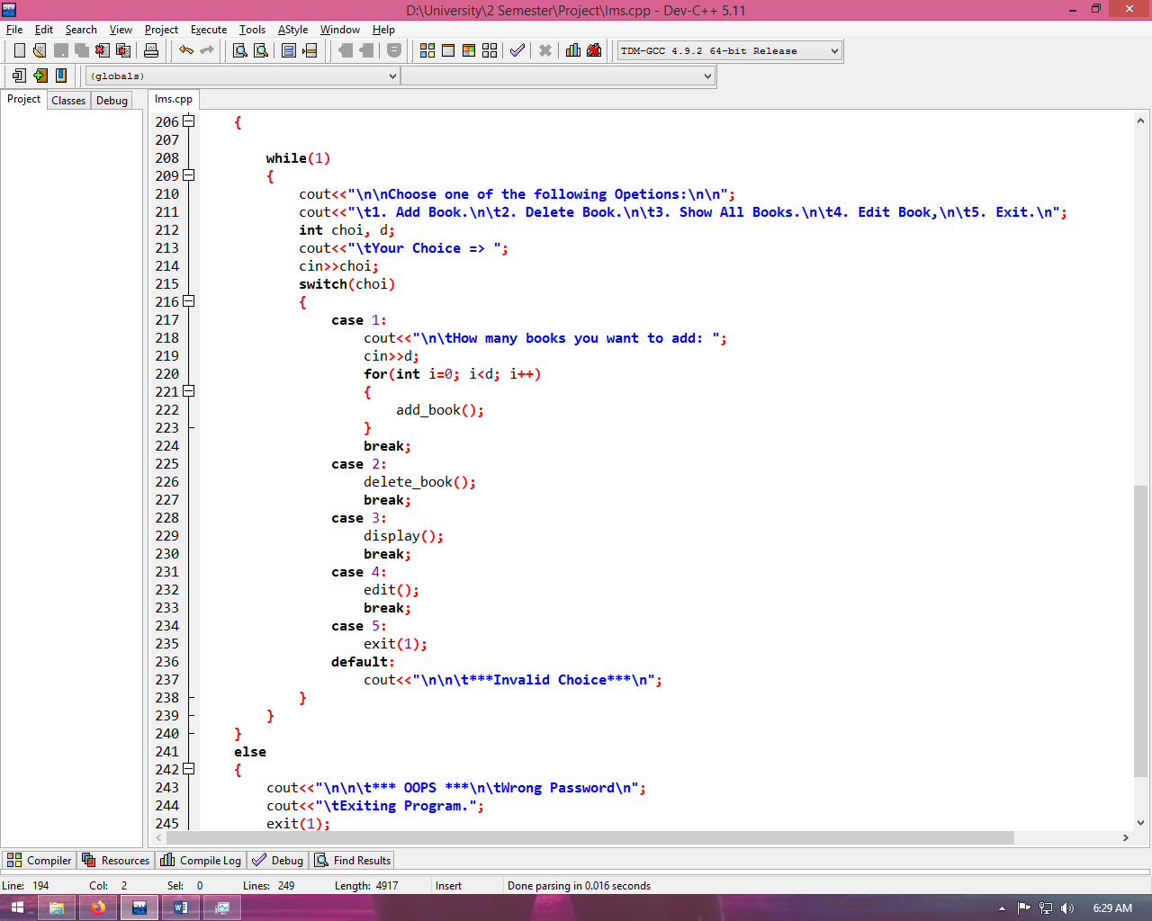

Figure 5

Figure 6

Figure 7

## **4.2 Graphs:**

Figure 8

## **4.3 Histograms:**

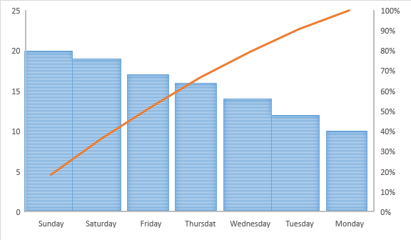

Figure 9

## **4.4 Simulations:**

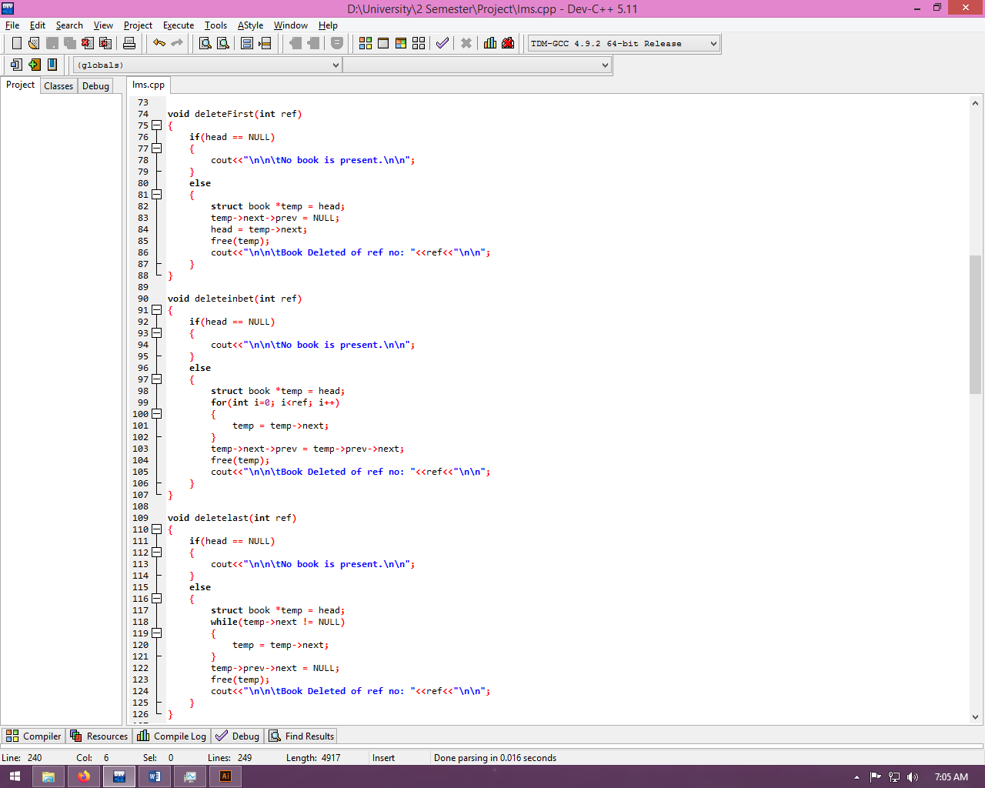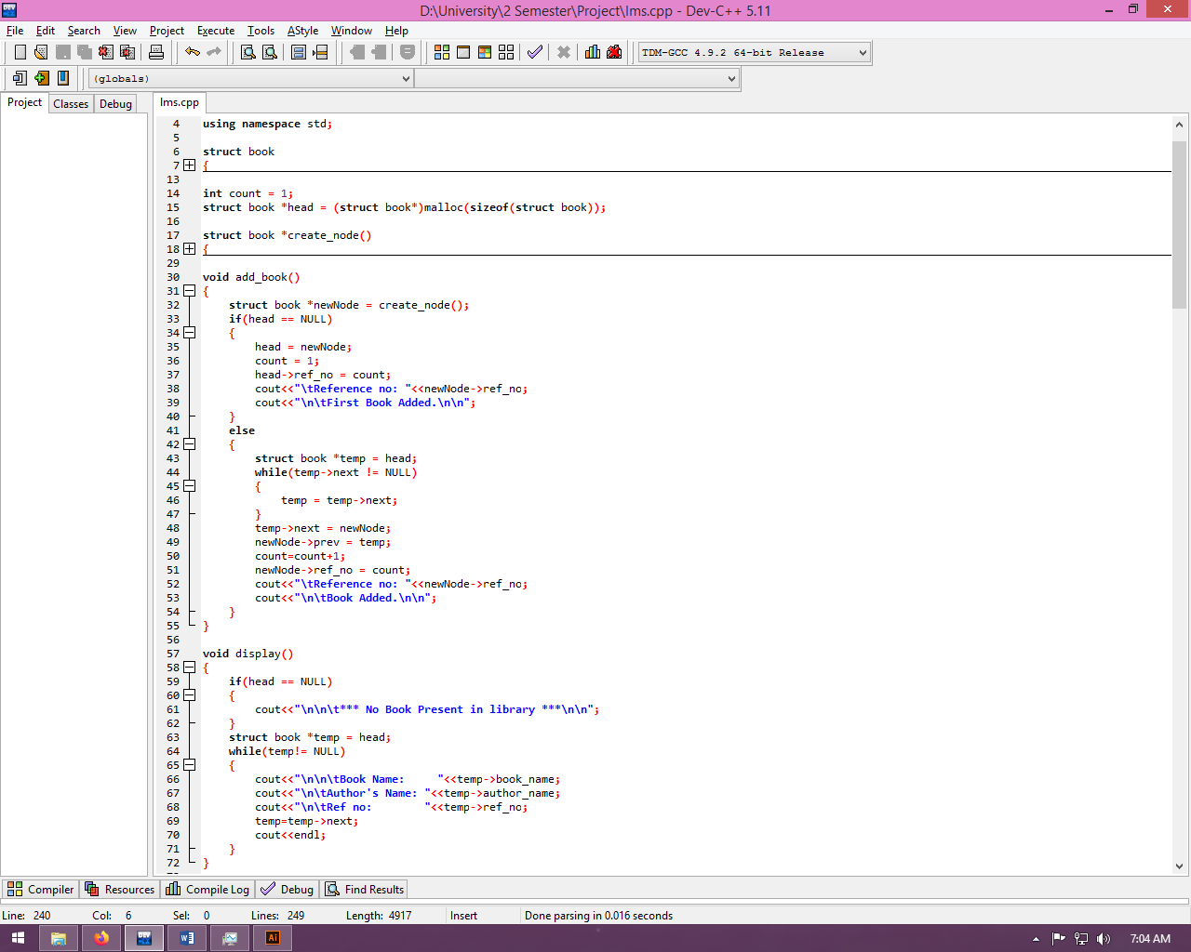

Figure 10

Figure 11

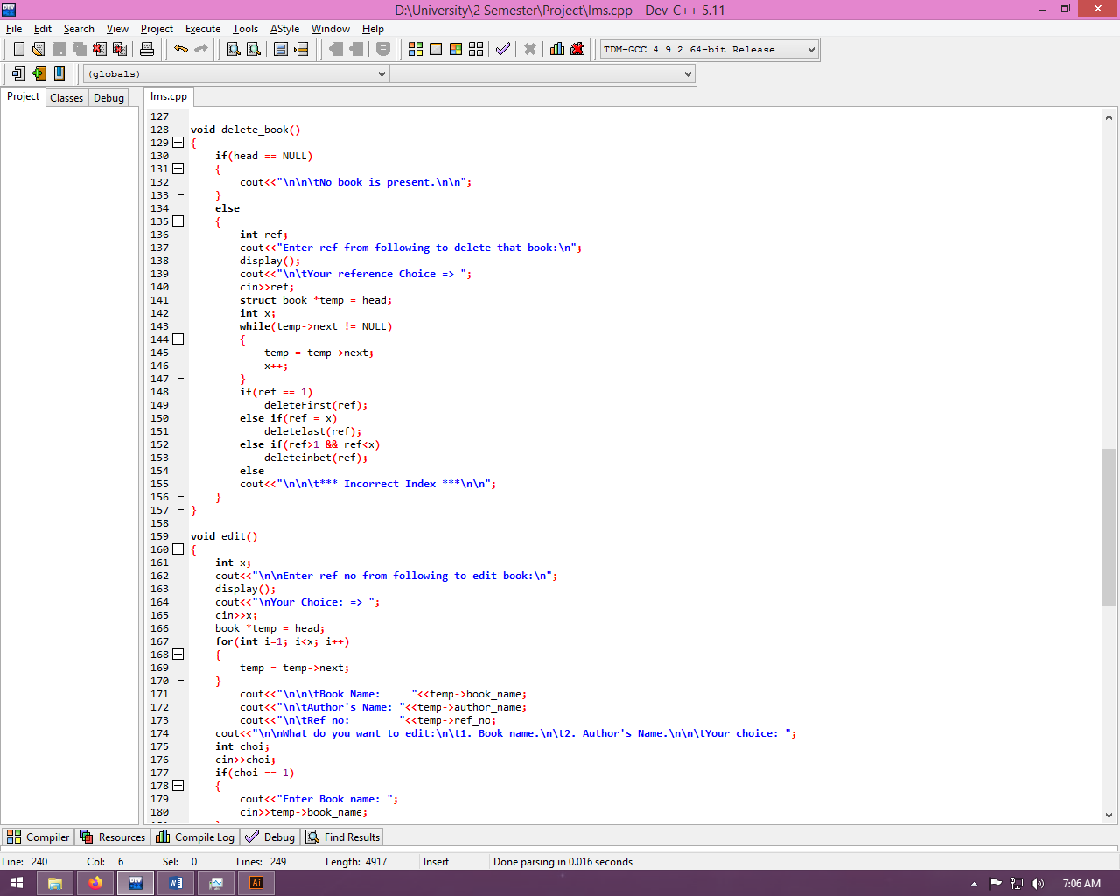

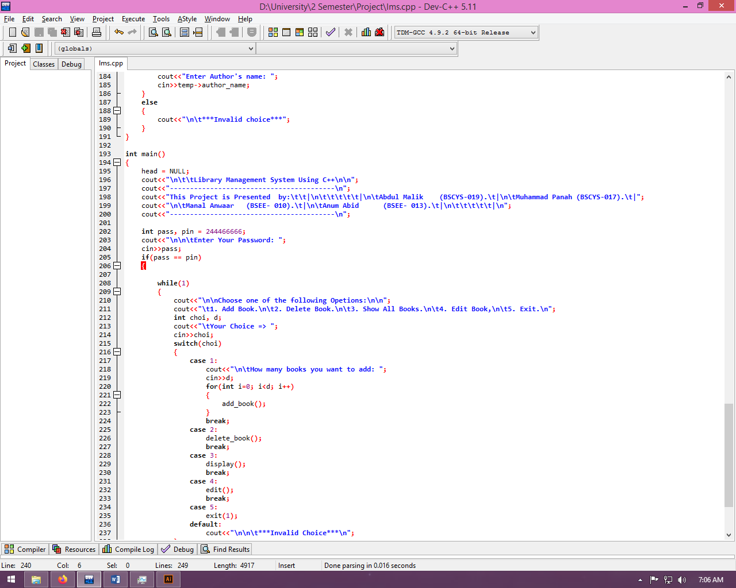Figure 12

Figure 13

## 

## **4.5 Tables:**

Figure 14

# 

# 5. Conclusion and Future Work:

## **5.1 Conclusion:**

The Library Management System allows the user to store the book details and the person’s details. This software allows storing the details of all the data related to library. The implementation of the system will reduce data entry time and provide readily calculated reports. The software keeps track of all the info about the books and their complete details.

## **5.1 Future Work:**

To assist the staff in capturing the effort spent on their respective working areas. To utilize resources in an efficient manner by increasing their productivity through automation. The system generates types of information that can be used for various purposes. Embracing sophisticated technologies is cost-effective and a viable choice for education institutions. Using cloud, mobile and digital libraries eliminates paper-based processes and maintenance overheads, improves productivity, reduces operation costs and saves time